Mineral Chemistry:
Let's break down and convert the chemistry of plagioclase from the mineral formula to atomic proportions and oxide units

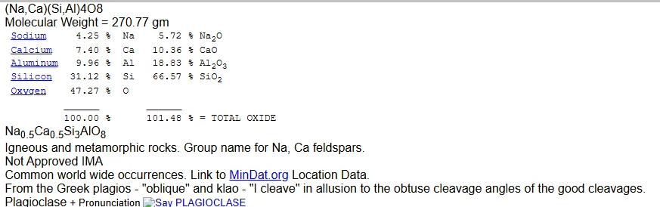
Ca = 40, K = 39, Si = 28, Al = 27, O = 16

MAKING INTERPRETATIONS FROM WHOLE ROCK DATA:
Here is a table showing whole rock analyses via XRF. Let’s analyse the chemical composition of this rock and find out what information we can extract from the XRF data.
Let’s break down the table’s data more specifically, focusing on the differences between the samples, and highlighting key elements and trends.
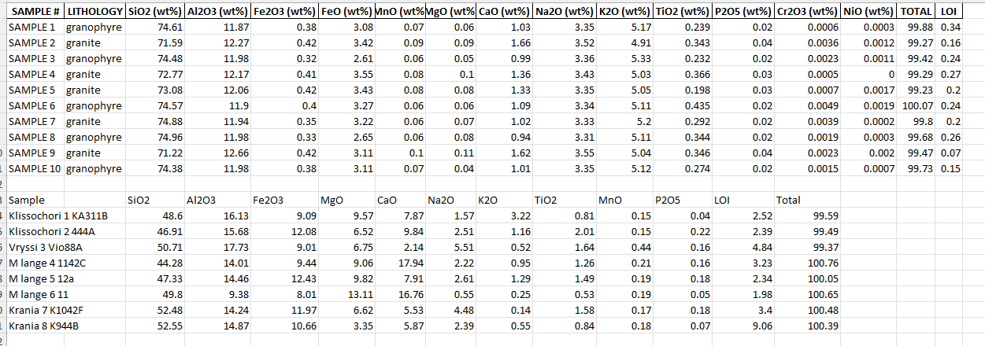

READING GEOCHEMICAL PLOTS:
Let’s consider the Geochemical Plots below. Let's plot the chemical data on the table above and describe the main rock units.

